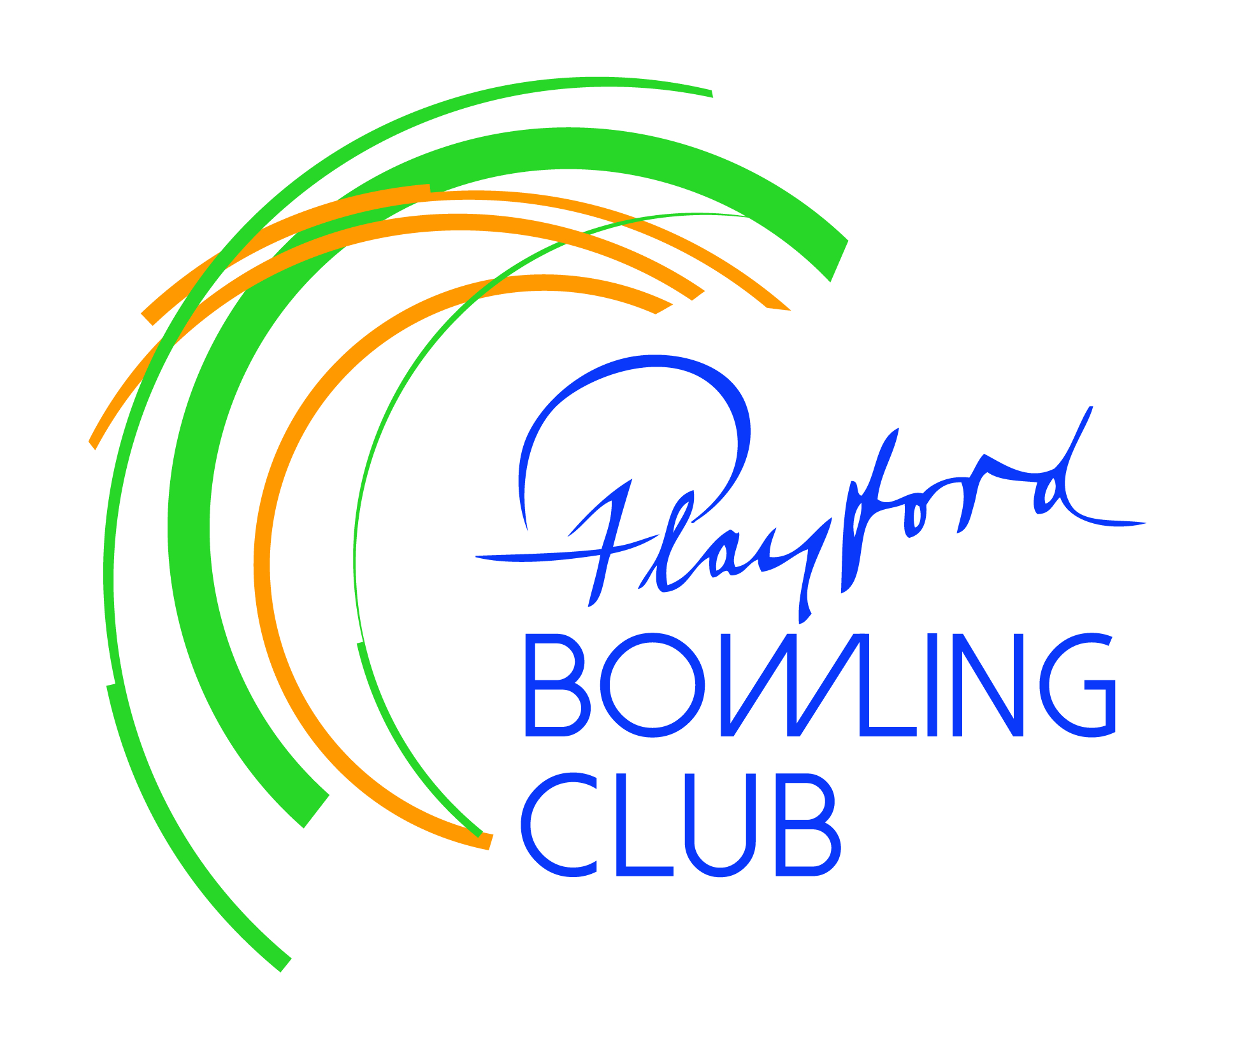
Playford Bowling Club Inc.
PO Box 34 Elizabeth SA 5112

April - May Newsletter

President’s Report

Despite the best efforts of the four teams taking part in finals campaigns, we narrowly missed out on securing the club’s seventh pennant. Our Saturday Div 5 side came second, losing their grand final at Payneham, but will nevertheless be promoted. Our Sat Div 3 side finished third – while a marked improvement on the eighth placing last year there is certainly a feeling of an opportunity lost, losing both home finals. Our Sat Div 4 side also came third - a mighty effort after gaining promotion the previous season – and our ladies team finished fourth. Pennants are difficult to win!!

So now we return to off-season social bowls on Wednesdays and Saturdays and we thank Marg and Ron for their ongoing organization of these sessions. Our random-draw approach means that you might end up in a very strong team, or you might partner some newbies to the sport – either way the focus is on enjoyment!

As another AGM approaches (see below) I want to thank the outgoing board for their prudent stewardship of our club. Thanks also to those members who have fulfilled the club’s various managerial roles over the past year, to the selectors who undertake a pretty thankless task and to the large band of dedicated volunteers who allow our young club to continue to flourish.

Congratulations to the finalists in our various club championships, who will be presented with trophies at the AGM. Each of the club’s perpetual trophies will be updated by the addition of an extra shield. Thanks to Tel Bettens for running the 2026 championships and dealing with the inevitable requests for match postponements and to Andy Crawford for staying behind on several occasions when participants neglected to check that the club was going to be open!

Steve Attridge

Junior Bowls Programme

Many thanks to Dean Huntley, Michael Keenan and Charlie Lang-Ashe, for running our first ever Junior Bowls Programme. About 10 very enthusiastic participants turned out each week, one of whom (Dean’s daughter Hannah) has already played 3 pennant matches with her dad, while another two have signed on as club members and will hopefully progress to pennant play next season.

Many bags of lollies were won at the final session for the season last Saturday. Each child was presented with a personalised certificate of participation and the programme now goes into recess until October. We plan to organise a couple of sessions between now and then to maintain contact.

Annual General Meeting

The 2026 AGM will be held at 2pm sharp on Sunday May 24 and all members are encouraged to attend – we need 40% attendance for a quorum. At this meeting we set the fees for the various membership classes for the 2026/27 season and also the honoraria attached to various positions within the club. We also elect members to fill vacancies on the Board of Management (BoM), and to serve as Chair of selectors (CoS) for each of the days on which we are involved in pennant competition. The AGM also provides an opportunity for members to propose changes to the constitution and to raise matters of concern.

This year we seek nominees for the following board positions: Men’s Vice-President, Ladies Vice-president, Secretary and two ordinary board members – all positions with two year terms.

Each CoS is elected for a one year term. The Cos does not select pennant sides but is responsible for ensuring that collectively selectors choose teams in accord with the club’s Selection Guidelines.

The responsibilities of each position will be posted on an AGM-dedicated noticeboard – please note that successful candidates will be required to complete a Personal Identification document and apply for a Working-with-children clearance. Nominees will need to be proposed and seconded by club members and lodge their nomination forms by close of business on May 10th.

We also invite nominations for the various managerial positions within the club, such as barperson, greens manager, kitchen manager and cleaner – each of which will be appointed for a one year term. Nominations for these positions will close after the AGM on May 24. The new BoM will select the successful candidates and its first board meeting.

Miscellaneous

Lyn Ruddock has resigned as our cleaner – thank you Lyn for your reliability and for the high standard of your work. Erilyn Dutton and Sam Goodwin will share the duties until a new cleaner is appointed at the first meeting of the new BoM.

Thanks to Craig and Ann-Mari Eckert and Erilyn Dutton for putting together the information folders on each table. These feature our various sponsors (please support them!) and information about upcoming tournaments and social events. PS Next schnitty night is June 5th.

